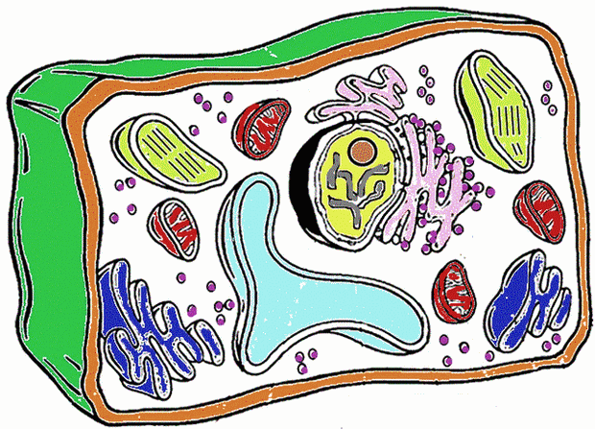 Table 1 Cell Organelles and Functions 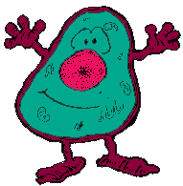

Organelle | Present in Plant or Animal Cell | Description | Function
Nucleus | Plant and Animal | Dark concentrated circular spot | Information control centre, “brain” of cell, controls cell functioning, contains genetic information.

